**HYPOTHESIS TESTING**

Hypothesis Testing in statistics is a method to test whether the results of an experiment are meaningful or not. Using Hypothesis Testing we are basically testing whether the results are valid by figuring out the odds that your results have occurred by chance. If your results have happened by chance, the experiment won’t be repeatable and so has little use.

**What is a Hypothesis?**

Hypothesis is a statement about something in the world around you. It should be testable, either by experiment or observation. For example:

* A new book which you might think is interesting
* A better way of experimenting which you might think is more effective.
* The possibility of an error in an experiment.

**What is a Hypothesis Statement?**

Before you propose a Hypothesis, it is very important to write a Hypothesis statement. A Hypothesis statement is of this format:

“If I do this (to an independent variable) then this will happen (to the dependent variable)”

Example:

* If you get at least 6 hours of sleep, you will do better on tests than if you get less sleep.
* If you get good rest, then you will feel fresh later.
* If you play football regularly, then your stamina will increase.

**Major concern regarding Hypothesis testing**

Hypothesis Testing is difficult as well as very important. Many students find this method difficult because they are unable to get the right hypothesis statement for that particular problem statement.

**Method to get the right Hypothesis**

* Reading the problem statement thoroughly.
* Identifying the independent and dependent variables.
* Performing background research.
* Creating a hypothesis.
* Check whether created hypothesis is testable.

**Let’s Start with Hypothesis Testing**

To begin with this method, first you need to know what Null Hypothesis and Alternative Hypothesis is.

**What is Null Hypothesis (H0)?**

A null hypothesis is a type of hypothesis used in statistics that proposes that there is no difference between certain characteristics of a population.

In other words, null hypothesis states that there is no relationship between two population parameters, I.e., an independent variable and a dependent variable.

Example:

* Question: Empire restaurant, selling Hyderabadi Chicken Dum biryani, claims that each parcel packet has 400 grams of biryani. You are sceptic of their claims and believe that on average each packet does not contain 400 grams of biryani. Null Hypothesis is that average grams in Biryani packet is 400 grams.

Hypothesis Testing becomes easy once Null hypothesis is determined. all you need to do is:

“Figure out your null hypothesis, state your null hypothesis, choose what kind of test you need to perform, either support or reject the null hypothesis.”

**Example:**

A school principal claims that students in her school score an average of 7 out of 10 in exams. The null hypothesis is that the population mean is 7.0. To test this null hypothesis, we record marks of say 30 students (sample) from the entire student population of the school (say 300) and calculate the mean of that sample. We can then compare the (calculated) sample mean to the (hypothesized) population mean of 7.0 and attempt to reject the null hypothesis. (The null hypothesis here—that the population mean is 7.0—cannot be proven using the sample data; it can only be rejected.)

**What is Alternative Hypothesis (H1)?**

The alternate/ alternative hypothesis is just an alternative to Null Hypothesis.

For example, in this Question: Empire restaurant, selling Hyderabadi Chicken Dum biryani, claims that each parcel packet has 400 grams of biryani. You are sceptic of their claims and believe that on average each packet does not contain 400 grams of biryani. Alternative Hypothesis is that average grams in Biryani packet is not equal to 400 grams.

**The idea of Hypothesis Testing:**

* Identify the Null Hypothesis
* State your Null hypothesis
* Decide the type of test to be performed
* Either support or reject the Null Hypothesis

**Types of tests under Hypothesis testing :**

* One Tailed test
* Two Tailed test

**One Tailed Test**

Here the test can be either **Lower tailed** or **Upper tailed** Test.

**Lower tailed test:**

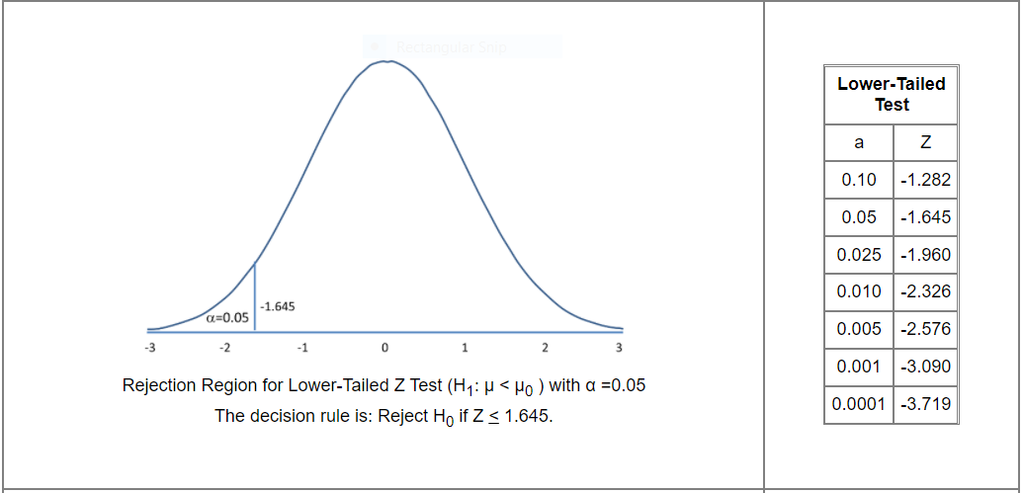

**H1: μ < μ 0**, where μ0 is the comparator or null value and an increase is hypothesized - this type of test is called a **Lower-tailed test**

**Example:**

You have developed a new Machine Learning Application and claim that on average it takes **less than** 100 milli seconds to predict for any future datapoint. Here you perform **Lower tailed test.**

**Upper tailed test:**

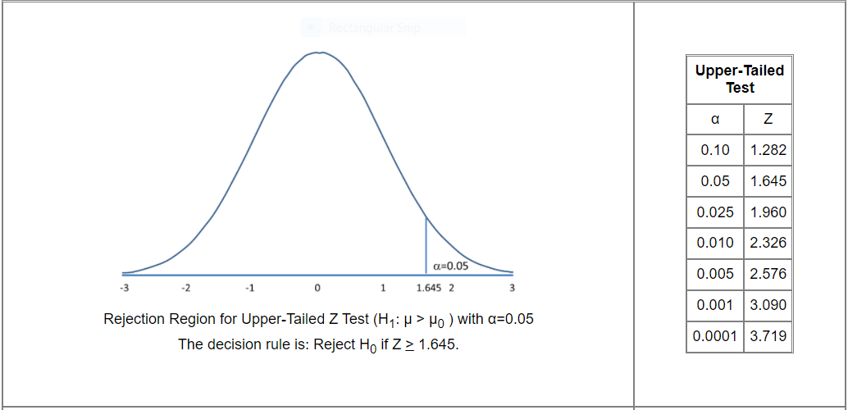

**H1: μ > μ 0**, where μ0 is the comparator or null value and a decrease is hypothesized - this type of test is called an **Upper-tailed test**

**Example:**

You have developed a new Machine Learning Application and claim that on average it takes **more than** 100 milli seconds to predict for any future datapoint. Here you perform **Upper tailed test**

**Two Tailed Test**

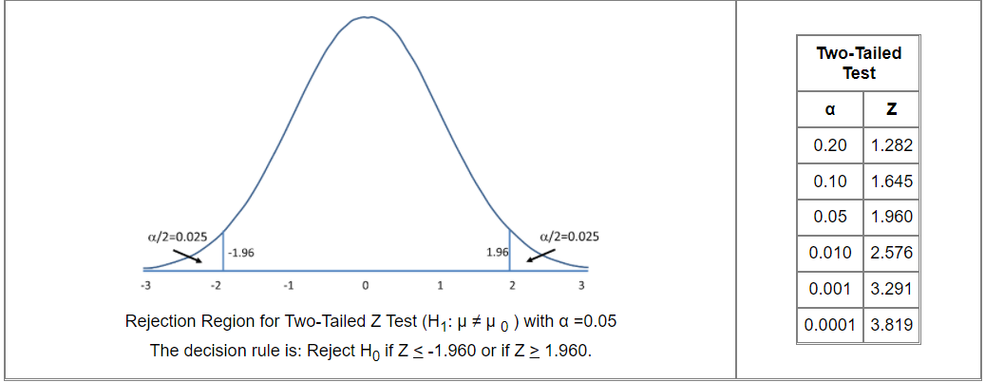

**H1: μ ≠ μ 0**, where a difference is hypothesized and this is called a **two-tailed test.**

**Example:**

Let’s consider one of our previous examples:

Empire Restaurant, selling Hyderabadi Chicken Dum biryani claims that each parcel packet has 400 grams of biryani. You are sceptic of their claims and believe that on average each packet does not contain 400 grams of biryani. Here we consider that the **average is not** 400 grams (**μ ≠ 400**). Here you perform **Two tailed test**.

**Note**:

**Concentrate on the bolden statements.**

**Steps to implement Hypothesis Testing:**

* Identify Null (Status Quo) and Alternative Hypothesis (Bold claim). For H1 we use **>, <** and ≠. For H0 we use **>=, <=** and =.
* Collect a sample of size n. Collect the mean from the sample x̄.
* Compute Test statistics:

1) If population variance is known.



2) If population variance is unknown.



* Decide the significance level α. Lower α means you need stronger evidence to reject Null hypothesis. **α= 1 – Confidence Interval.** α is considered for one tailed tests and α/2 is considered for two tailed tests.
* Apply Decision rule:

If test statistics is z-score:

1) Two tailed z-test:

|z| > zα/2 , then Accept H1 or reject H0

2) Upper tailed z-test:

z > zα , then Accept H1 or reject H0

3) Lower tailed z-test:

z < -zα , then Accept H1 or reject H0

If test statistics is t-score:

1) Two tailed t-test:

|t| > tn-1,α/2 then Accept H1 or reject H0

2) Upper tailed t-test:

t > tn-1,α then Accept H1 or reject H0

3) Lower tailed t-test:

t < -tn-1,α , then Accept H1 or reject H0

**QUESTIONS:**

1. The Empire Restaurant, selling Hyderabadi Chicken Dum biryani claims that each parcel packet has 500 grams of biryani. You are sceptic of their claims and believe that on average each packet does not contain 500 grams of biryani. How do you prove your claim? (Given that the population std is 50)

**SOLUTION**

**Step 1:**

Alternative Hypothesis (Bold claim) : µ ≠ 500

Null Hypothesis (status quo) : µ = 500

**Step 2:**

* **Collect a sample of size n =10 (sample size)**
* **Consider sample [490,220,470,500,495,496,496,498,508,480]**
* **Computing sample mean x̄ = [490+220+470+500+495+496+496+498+508+480]/10 = 465.3**
* **Population mean = 500 (µ = 500)**
* **Population standard deviation 50 (σ)**

**Step 3:**

Computing Test Statistics: z-score



**Step 4:**

Let confidence level be 0.95.

Therefore, Significance level or α = 1- Confidence level = 1 - 0.95 = 0.05

**Step 5:**

To calculate z-score we have to identify the type of test to be used.

Here, since Null Hypothesis: µ = 500

Therefore, it is two tailed test. Here, we consider α/2 as significance level.

Calculating z-score using formula,

**Z = -2.1946**

Calculating z-critical value from table.

We get **z-critical = 1.9599**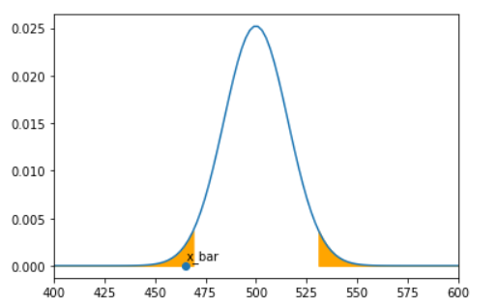

Finally, we get

**|z|> z-critical**

Therefore, we can reject Null Hypothesis.

1. The Empire Restaurant, selling Hyderabadi Chicken Dum biryani claims that each parcel packet has 500 grams of biryani. You are sceptic of their claims and believe that on average each packet does not contain 500 grams of biryani. How do you prove your claim? Here standard deviation of population is not given .

**SOLUTION**

**Step 1:**

Alternative Hypothesis (Bold claim) : µ ≠ 500

Null Hypothesis (status quo) : µ = 500

**Step 2:**

* **Collect a sample of size n =10 (sample size)**
* **Consider sample [490,220,470,500,495,496,496,498,508,480]**
* **Computing sample mean x̄ = [490+220+470+500+495+496+496+498+508+480]/10 = 465.3**
* **Population mean = 500 (µ = 500)**
* **Sample standard deviation S = StdDeviation(sample)**

**Step 3:**

Computing Test Statistics: t-score

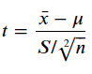

**Step 4:**

Let confidence level be 0.95.

Therefore, Significance level or α = 1- Confidence level = 1 - 0.95 = 0.05

**Step 5:**

To calculate t-score we have to identify the type of test to be used.

Here, since Null Hypothesis: µ = 500

Therefore, it is two tailed test. Here, we consider α/2 as significance level.

Calculating t-score using formula,

**t = -1.3318**

Calculating t-critical value from table.

We get **t-critical = 1.9604**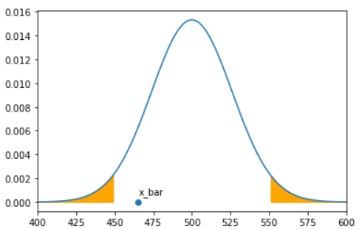

Finally, we get

**|t|< t-critical**

Therefore, we fail to reject Null Hypothesis.

1. You have developed a new Algorithm and done a user study. You claim that the average rating given by the users **is greater than** 4 on a scale of 1 to 5. How do you prove this to your client? (Given that the population std is 0.5)

**Solution**

**Step 1:**

Alternative Hypothesis (Bold claim) : µ >4

Null Hypothesis (status quo) : µ <= 4

**Step 2:**

* **Collect a sample of size n =20 (sample size)**
* **Consider sample [4,3,5,4,5,3,5,5,4,2,4,5,5,4,4,5,4,5,4,5]**
* **Computing sample mean x̄ = [4+3+5+4+5+3+5+5+4+2+4+5+5+4+4+5+4+5+4+5]/10 = 4.25**
* **Population mean = 4 (µ = 4)**
* **Population standard deviation = 0.5 (σ)**

**Step 3:**

Computing Test Statistics: z-score



**Step 4:**

Let confidence level be 0.95.

Therefore, Significance level or α = 1- Confidence level = 1 - 0.95 = 0.05

**Step 5:**

To calculate z-score we have to identify the type of test to be used.

Here, in this question it it given that user’s rating is **greater than 4** on a scale of 1 to 5)

Therefore, it is Upper one-tailed test. Here, we consider α as significance level.

**NOTE:**

If the question states that the user’s rating is **lower than 4** on a scale of 1 to 5, then we would consider Lower one tailed test.

Calculating z-score using formula,

**Z = 2.2360**

Calculating z-critical value from table.

We get **z-critical = 1.6448**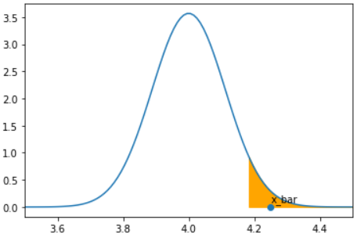

Finally, we get

**|z|> z-critical**

Therefore, we can reject Null Hypothesis.